1. Let’s review lock before understanding semaphore.
2. 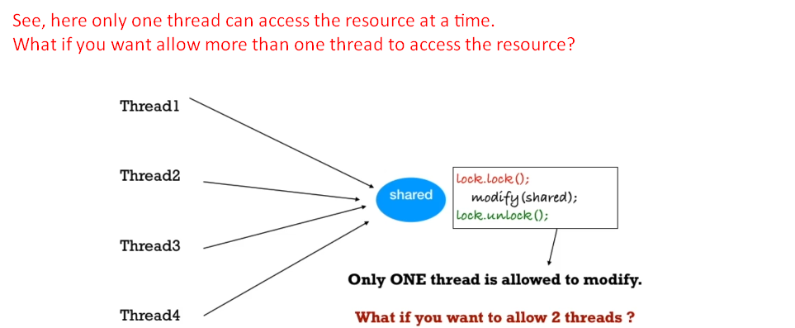
3. **Scenario**: What if we have two printers and we want to allow two threads to access the prints.
   1. Here we can use Semaphore.
   2. Suppose Semaphore holds 2 permits.
4. 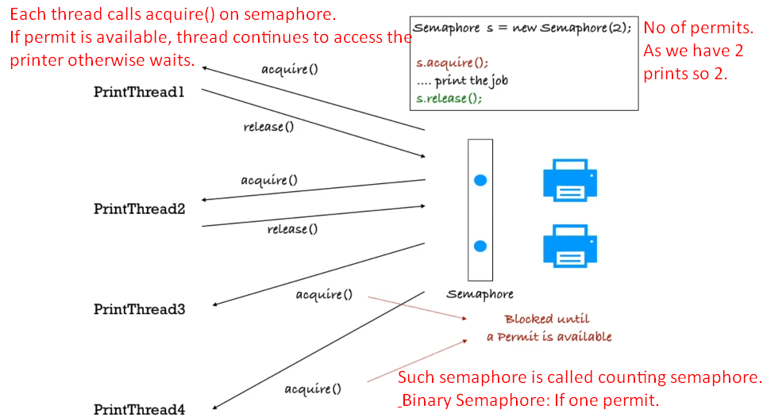
5. 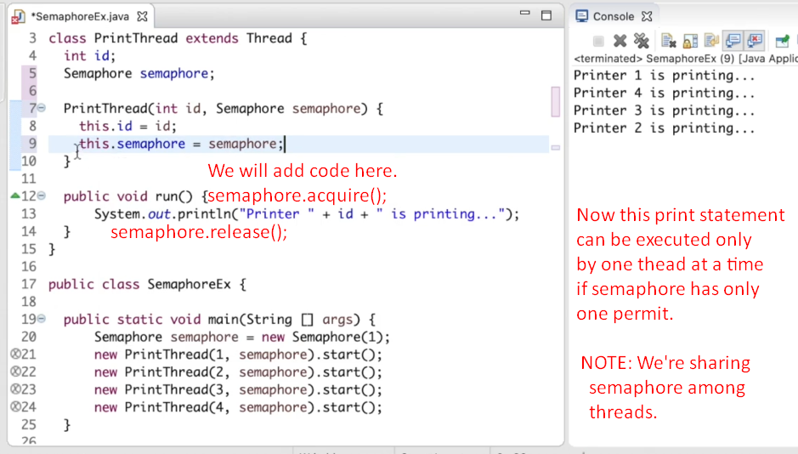
6. **Other Application**:
   1. To implement Connection Pool. As we have limited no of units of a resource.